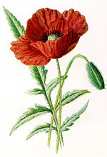

Anzac Day Centenary, 2015 – Saturday April 25

On Anzac Day we will be attending the Dawn Service at Simpson Barracks and later will participate in the Greensborough Anzac Day March (this is the one attended by most Banyule District Scout Groups). FULL Uniform to be worn (white scarf for Cub New Chums!). If you can’t make it to the Dawn Service, please try to get to the March later on. Note that this is for Cubs and for any Scouts not attending Services in the City.

Anzac Day Dawn Service

The Service starts 6.00am Sharp at Simpson Barracks – assemble at 5:30 - enter off Yallambie Road (Melway 20 F6). You will be directed where to park (tons of cars!). Dress Warmly.
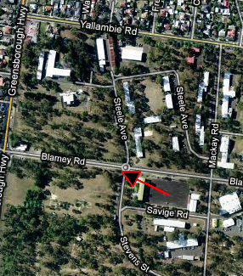
To try to keep the Group together (large crowd), families should try to meet at the corner of Blamey Rd and Stevens St (see map) by 5:30am. If you don’t meet up with our Leaders there, continue on with your family and participate in the service!


Breakfast is usually available afterwards for those who wish to buy it.

Anzac Day March
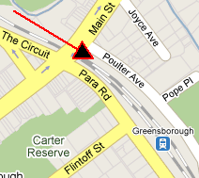
We’re participating in the Greensborough march. Meet at the carpark off Poulter Ave (opposite Greensborough RSL), Greensborough - Melway Map 20 K1

Be there by 8.30am to get ready for the start.

The March will proceed up the hill to Memorial Park in Henry Street for the Anzac Service. Refreshments will be provided for the Cubs and Scouts at Greensborough R.S.L. afterwards.

Remember: On top of the significance of Anzac Day for us, participation in at least one of the Services is also part of the Heritage Badge (‘Their Service, Our Heritage’). This year there is a special “100 year” Heritage Badge. If you take part in another Anzac Day service (preferably in Uniform), please let us know so your attendance can still count.



Queries? Contact: Akela 0411 121 495 - akela@rosannacubs.org, or Michelle 0429 377 660 - michelle@rosannascouts.org

